
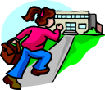
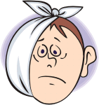
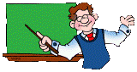
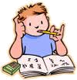
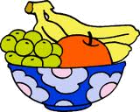
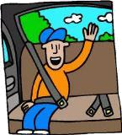
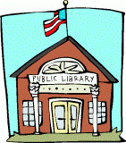
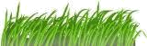
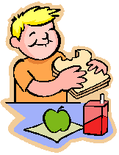
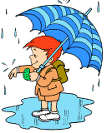
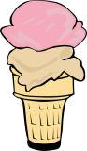
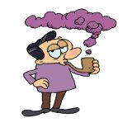
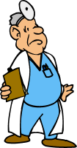
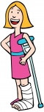
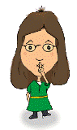
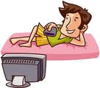
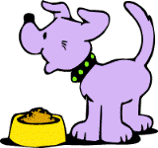
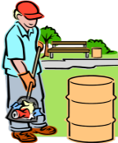
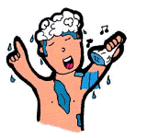
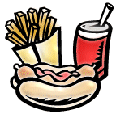
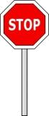

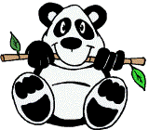
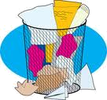
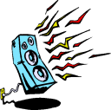
Complete the sentences with must or mustn’t.
You _ _ _ _ _ be late for school.
You _ _ _ _ _ go to the dentist with a toothache.
A teacher _ _ _ be a patient person.
You _ _ _ _ _ speak loudly in a library.
It’s raining. You
_ _ _ _ _ take your umbrella.
You _ _ _ _ _ stop when you see that sign.
You _ _ _ _ _ eat in class.
You _ _ _ _ _ keep off the grass!
You _ _ _ _ _ take a cough syrup once a day.
You _ _ _ _ _ tell my secret to anybody.
You _ _ _ _ _ watch too much television.
You _ _ _ _ _ fasten your seat belt in a car.
You _ _ _ _ _ eat junk food too often.
You _ _ _ _ _ feed your pet twice a day.
You _ _ _ _ _ run with a broken leg.
We _ _ _ _ _ protect endangered species.
You _ _ _ _ _ have a shower every day.
You _ _ _ _ _ forget about Mother’s Day.
You _ _ _ _ _ put the rubbish in a bin.
You _ _ _ _ _ eat more fruit.
You _ _ _ _ _ listen to loud music after 10 p.m.
You _ _ _ _ _ stop smoking. It’s bad for you.
Students _ _ _ _ forget their homework.

You _ _ _ _ _ keep the park clean.
You have a sore throat. You _ _ _ _ _ eat ice cream.

Complete the sentences with must or mustn’t.
You _ _ _ _ _ be late for school.
You _ _ _ _ _ go to the dentist with a toothache.
A teacher _ _ _ be a patient person.
You _ _ _ _ _ speak loudly in a library.
It’s raining. You
_ _ _ _ _ take your umbrella.
You _ _ _ _ _ stop when you see that sign.
You _ _ _ _ _ eat in class.
You _ _ _ _ _ keep off the grass!
You _ _ _ _ _ take a cough syrup once a day.
You _ _ _ _ _ tell my secret to anybody.
You _ _ _ _ _ watch too much television.
You _ _ _ _ _ fasten your seat belt in a car.
You _ _ _ _ _ eat junk food too often.
You _ _ _ _ _ feed your pet twice a day.
You _ _ _ _ _ run with a broken leg.
We _ _ _ _ _ protect endangered species.
You _ _ _ _ _ have a shower every day.
You _ _ _ _ _ forget about Mother’s Day.
You _ _ _ _ _ put the rubbish in a bin.
You _ _ _ _ _ eat more fruit.
You _ _ _ _ _ listen to loud music after 10 p.m.
You _ _ _ _ _ stop smoking. It’s bad for you.
Students _ _ _ _ forget their homework.

You _ _ _ _ _ keep the park clean.
You have a sore throat. You _ _ _ _ _ eat ice cream.

Complete the sentences with must or mustn’t.
You mustn’t be late for school.
You must go to the dentist with a toothache.
A teacher must be a patient person.
You mustn’t speak loudly in a library.
It’s raining. You
must take your umbrella.
You must stop when you see that sign.
You mustn’t eat in class.
You must keep off the grass!
You must take a cough syrup once a day.
You mustn’t tell my secret to anybody.
You mustn’t watch too much television.
You must fasten your seat belt in a car.
You mustn’t eat junk food too often.
You must feed your pet twice a day.
You mustn’t run with a broken leg.
We must protect endangered species.
You must have a shower every day.
You mustn’t forget about Mother’s Day.
You must put the rubbish in a bin.
You must eat more fruit.
You mustn’t listen to loud music after 10 p.m.
You must stop smoking. It’s bad for you.
Students mustn’t forget their homework.

You must keep the park clean.
You have a sore throat. You mustn’t eat ice cream.

