    1. Write my,your, his, her, its, our or their.  Possessive adjectives  a) Marion and Helen are students. .................... school is big.  b) I’m a taxi driver. This is............taxi.  c) You’re a musician. Is that..........piano?  d) The horse is brown. ............tail is black.  e) He’s a doctor. This is...........coat.  f) We are tennis players. These are .................. tennis racquets.  g) Pam is a photographer. This is..........camera.  h) That is Jim and Mike. ......... father is Welsh. |  |   2. Choose A or B.  a) These are..........boots. a)he’s b) his  b) Is Anne’s skirt long? Yes, ......... skirt is long. a) her b) its  c) This isn’t my dress. Is it........... dress? a) you b) your  d) That’s...........family. a) I b) my  e) Is this the woman’s scarf? Yes, it is ............ scarf. a) their b) her  f) The cat is fat. ........ tail is long.  a) his b) its
3. Look and write as in the example.  - His name is Tom. His favourite pet is a cat.  - ........................................................................  - ........................................................................  - ........................................................................ |  | 4. Complete.  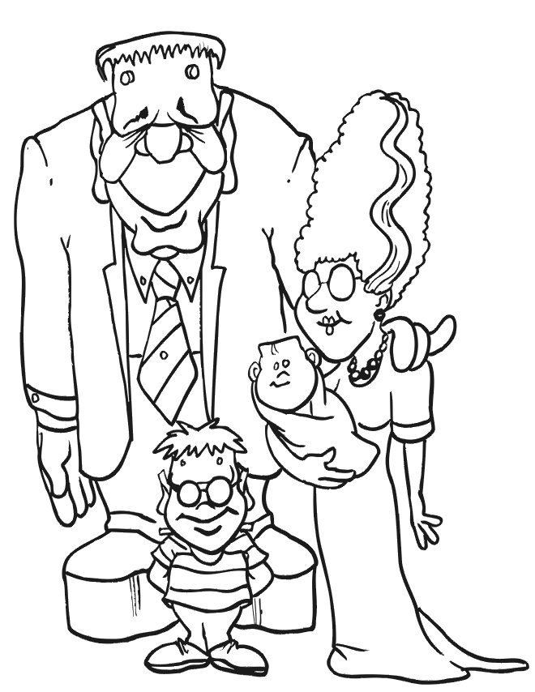  These are............ parents. .............. names are Stewie and Mandy. This is .........baby sister Janet and that is .........blanket. ........... brother Sam is eleven years old and those are...........glasses.
  Name | TOM | PAM | JOHN | TIM/OZ
  Favourite Pet | CAT | DOG | FISH | PARROT

5. Complete each chart.   |  | 6. Fill in with the correct possessive adjective.  a) I’ve got a ruler. It’s my ruler.  b) You’ve got a car. It is...........car.  c) John’s got a CD. It’s..............CD.  d) We’ve got a pet. It’s...............pet.  e) Pam’s got a pen. It’s.............pen.  f) I’ve got crayons. They’re ............... crayons.  g) They’ve got a house. It’s .............. house.  h) She’s got a glue. It’s............glue.  i) Tom and I have got new friends.  They are.................friends.  j) Maria’s got a desk. It’s .........desk  k) My parents have got new jobs.  They are..............jobs.
  A boy in my class
  ...........name is....................................
  ..........surname is...............................
  
  ..........is...................years old.
  ...........eyes are..................................
  ...........hair is......................................
  A girl in my class
  ...........name is....................................
  ..........surname is...............................
  
  ..........is...................years old.
  ...........eyes are..................................
  ...........hair is......................................

